Introduction
- A few paragraphs explaining what the research question is, and why you are using this approach. No need to do a literature review, just make it clear what you are doing and why. Have a clear scientific question which will drive the model development.

Methods
- Describe the sampling design and data.
- Give the equations for your generative model and explain why you set it up the way you did.
- Describe all the alternative models you considered.
- Describe the convergence validation, model checking, simulation and model comparison methods to be used.

Results
- Give the convergence diagnostics and model fit diagnostics.
- Some simulation tests (prior and posterior)
- Show the posteriors and summaries for the estimated parameters and any relevant derived parameters.
- Show any relevant probabilities or summary statistics.

Discussion
- This can be brief. Focus on the implications of the results, any caveats about the data or the models, and future avenues of research.

Introduction

Fernando de Noronha Archipelago (FEN) is an isolated group of volcanic islands located 345 km off the Brazilian coast and is listed as a World Heritage Site. Additionally, FEN was recently recognized as a Mission Blue Hope Spot for its global conservation and ecological significance. Recent tiger shark (Galeocerdo cuvier) severe bites in the Praia do Sueste, however, have led to some calls to institute a shark cull given FEN’s status as one of the top ecotourism destinations in Brazil and its reliance on a growing number of visitors all year round. Considering that FEN has been identified as an important genetic hotspot for G. cuvier, there is an urgent need to understand the occurrence and ecological role of this species in this biologically significant area. Understanding the contexts in which shark–turtle interactions can cascade to wider community dynamics is important for predicting ecosystem responses to shark overfishing and sea turtle population changes. Preliminary data from drones, however, suggests that Praia do Sueste provides an unprecedented opportunity to study tiger shark–turtle interactions due to the densities of both species and the shallow waters within this bay.

The main biological question I am trying to address with this work is whether tiger sharks’ (Galeocerdo cuvier) space-use patterns within Praia do Sueste varies with month, tide height and moon illumination, while accounting for differences between years. This work will add insight into why, where and how tiger sharks use this bay.

METHODS
Study design and data

Tiger shark habitat use was analyzed using drone-derived movement tracks collected within Praia do Sueste, Fernando de Noronha, Brazil. Each shark track consisted of a sequence of spatial positions extracted from drone footage and georeferenced over time. Because the objective of the study was to evaluate whether habitat use varied across time, each track was associated with its date of observation, allowing comparisons among years and months.

A GPS point for every 2-second interval seemed to best capture the fine-scale movement pattern observed in the field. Because the data consists of repeated shark positions extracted from drone footage, I was concerned that raw coordinates could contain GPS observation errors and biologically unrealistic locations, which could influence spatial-use estimates. To address this, I first cleaned the tracks and removed impossible points (e.g., positions falling on land), and then fit a Bayesian correlated random walk (CRW) state-space model to estimate latent “true” positions while accounting for GPS error. I used this as the main Bayesian component of the workflow because it seemed the best way to handle positional uncertainty in the movement paths.

Results
GAM Y:
Deviance explained: 0.2618433
Adjusted R2: 0.2319635

GAM X:
Deviance explained: 0.2962323
Adjusted R2: 0.2628679

Discussion

Figures I intend to use

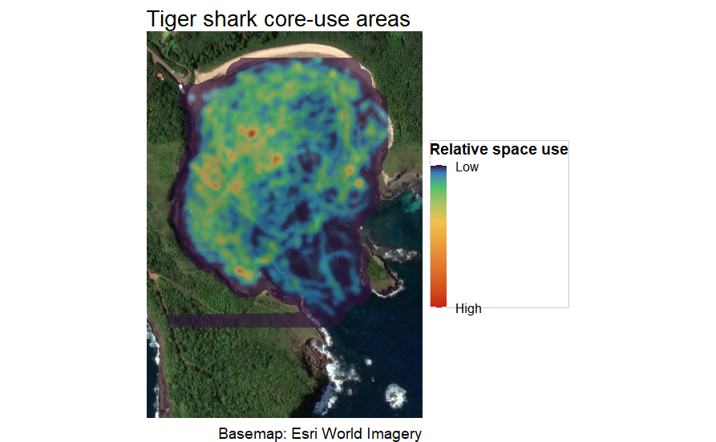
Figure 1. Kernel density estimate of tiger shark space use overlaid on satellite imagery. Warmer colours indicate areas of higher relative space use, whereas cooler colours indicate lower relative space use.

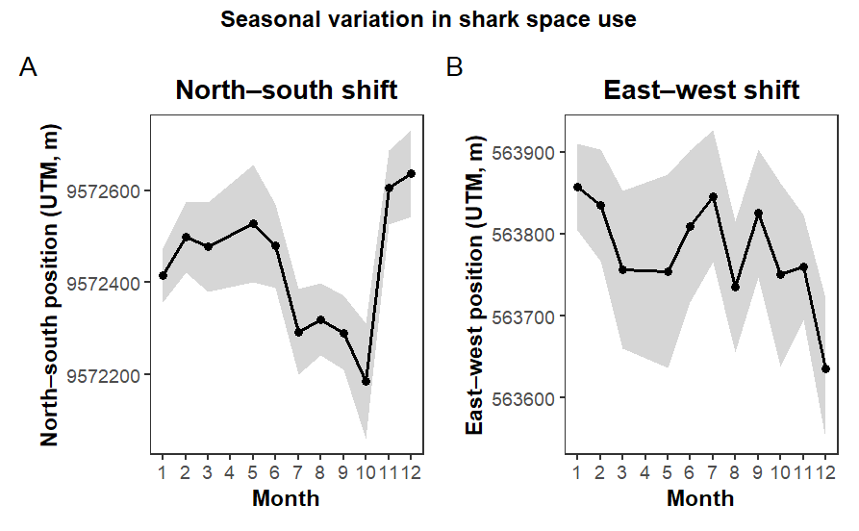
Figure 2. Predicted seasonal variation in shark space use from track-level generalized additive models. Panel A shows predicted north–south position and Panel B shows predicted east–west position across months (1–12). Predictions were generated while holding year constant and environmental covariates (tide height and moon illumination) at their mean values. Shaded areas represent 95% confidence intervals.

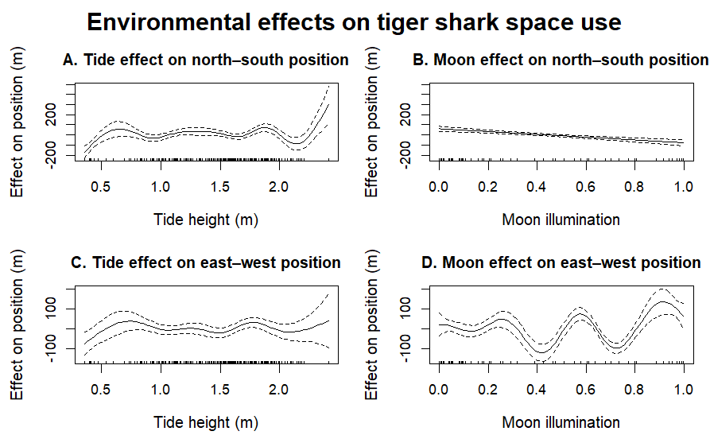
Figure 3. Effects of environmental drivers on tiger shark space use from track-level generalized additive models. Panels A and C show the effects of tide height on north–south and east–west position, respectively, while Panels B and D show the corresponding effects of moon illumination. Solid lines represent estimated smooth effects, dashed lines indicate 95% confidence intervals, and rug plots show the distribution of observed values.

